FK10N - FK10N - Vendor Account Balance

Functionality
Every time you post a document, the system automatically updates a vendor account and the relevant GL account (reconciliation account) balance.
This document covers Vendor Account Balance Analysis. The account balance displays:
- The opening balance (the balance carried forward from the previous year)
- The total of all transactions for each posting period, broken down into debit and credit postings (transaction figures)

Scenario
You want to check and print a vendor account balance.

Requirements

Defined Vendor Master and posted vendor documents.

Menu Path | Accounting → Financial Accounting → Accounts Payable → Account → FK10N - Display balances
Transaction Code | FK10N

1. Double click on FK10N - Display balances

Vendor Balance Display

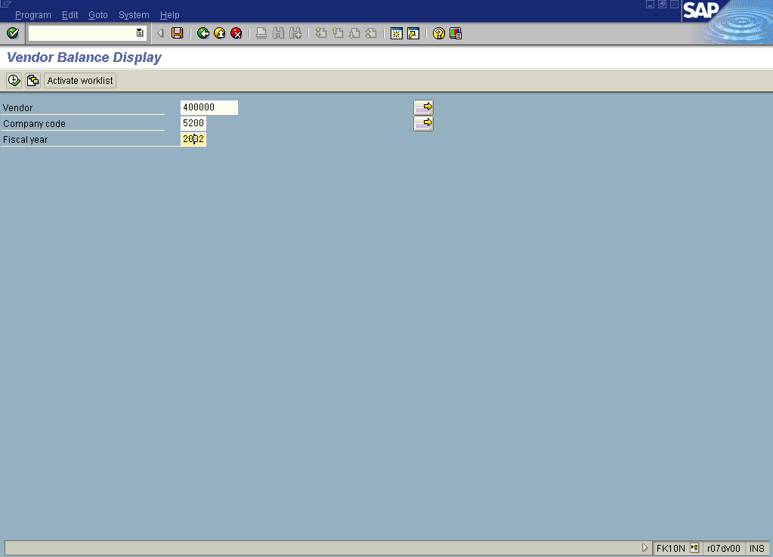

2. Update the following fields:

Field Name | Field Description | Values
Vendor | Code identifying the vendor account | Example: 400000
Company code | Code identifying a separate legal entity for which a separate set of accounts is maintained for external reporting purposes | Example: 5200
Fiscal year | Fiscal year number | Example: 2002

3. Click Enter to confirm your entries.

4. To display a report, click Execute .

Vendor Balance Display

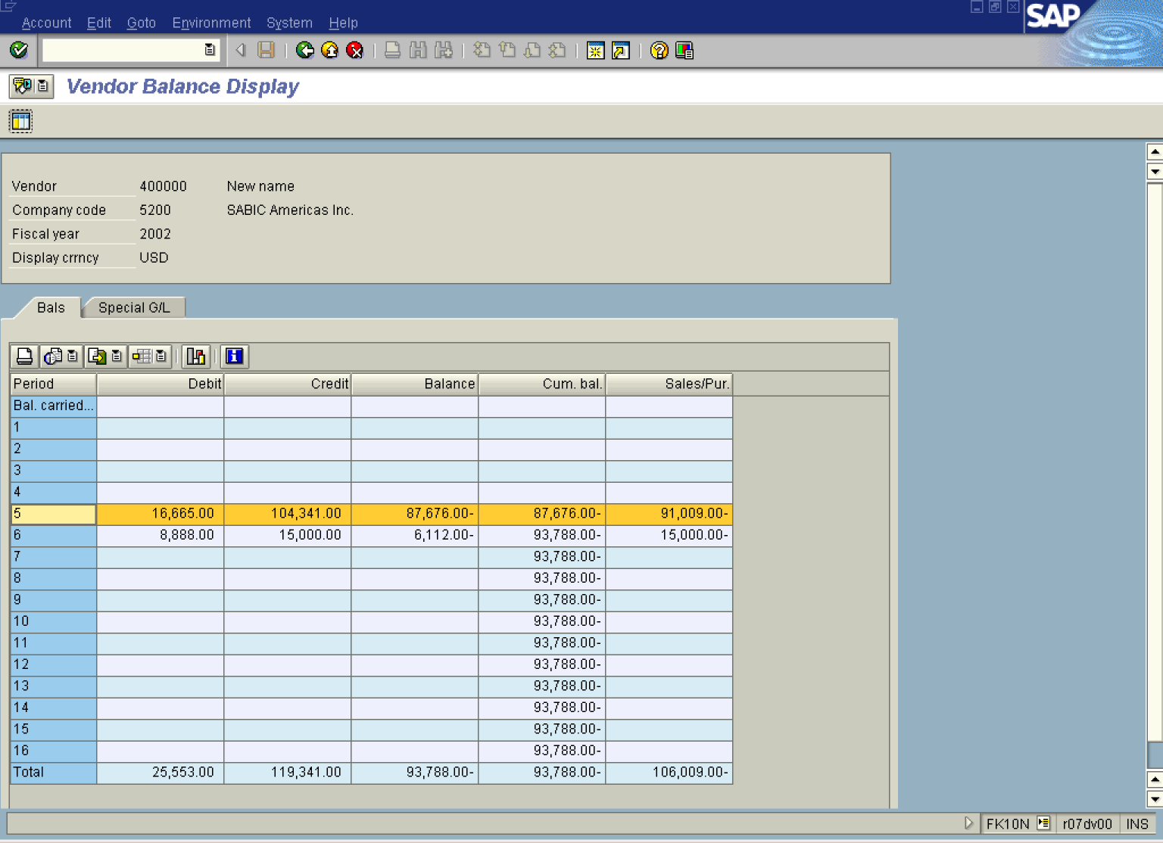

5. You can display the line items or even particular document directly from this report. For instance, to display all the documents for May 2002 mark this row on the repot screen (it will be highlighted in yellow) and click Call up line item report Button . You can see now all the documents posted in May:

Vendor Line Item Display

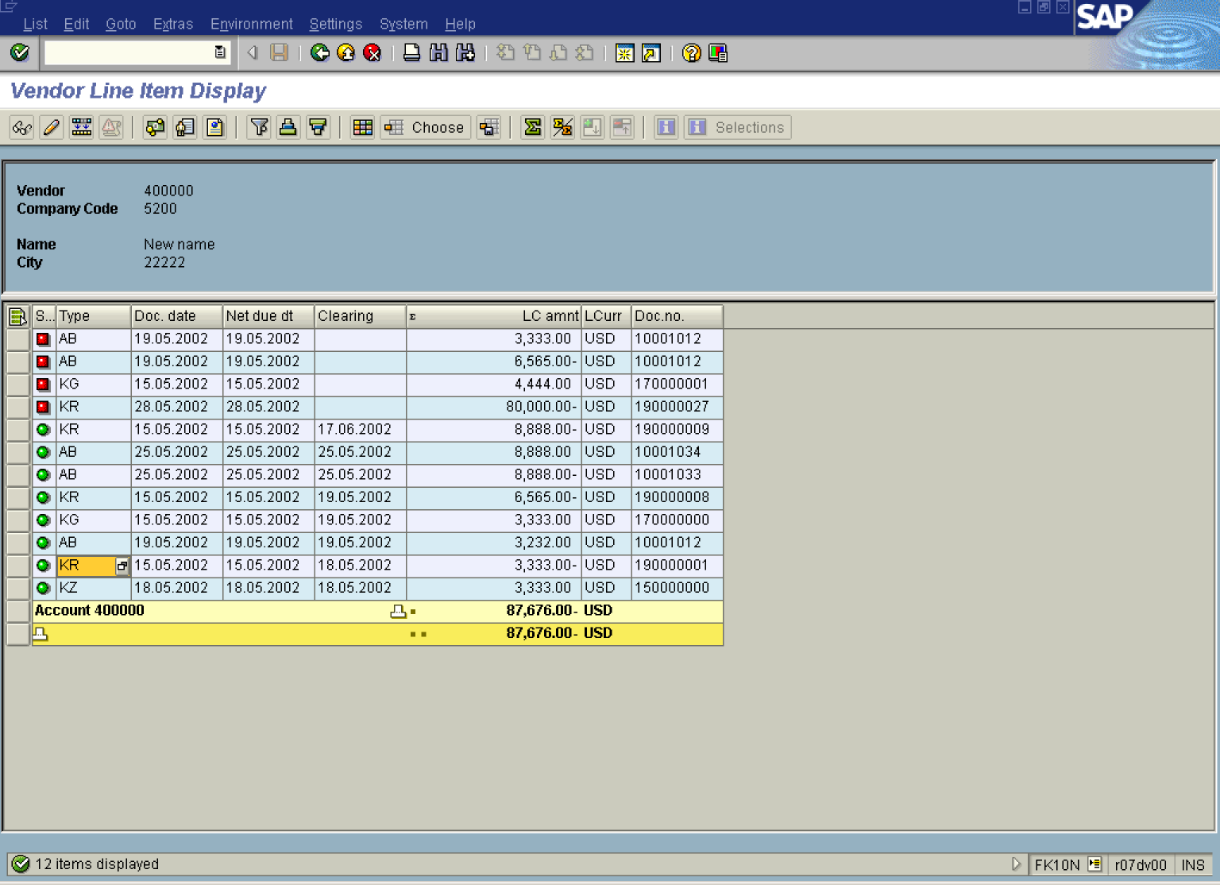

6. To display the details of a particular line item simply double-click on it. The system will display this line item:

Display Document: Line Item 001

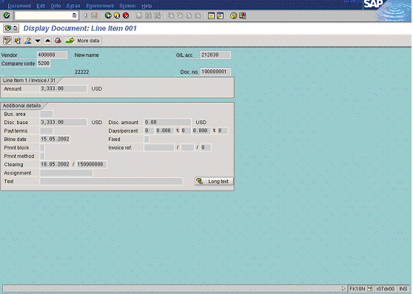

7. If you need, you can change some of the fields. Click Display -> Change Button . The fields that can be changed are highlighted in red. For instance you can add the description of the field “Assignment”:

Change Document: Line Item 001

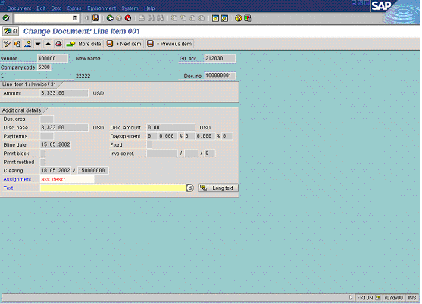

8. Update the following fields:

Field Name | Field Description | Values
Assignment | Additional document description | Example: ass. descr.

9. Click Save Button. to update this document.

10. You can also export the account balance to a local file. Select from the menu path: ListExportLocal file…

Vendor Line Item Display

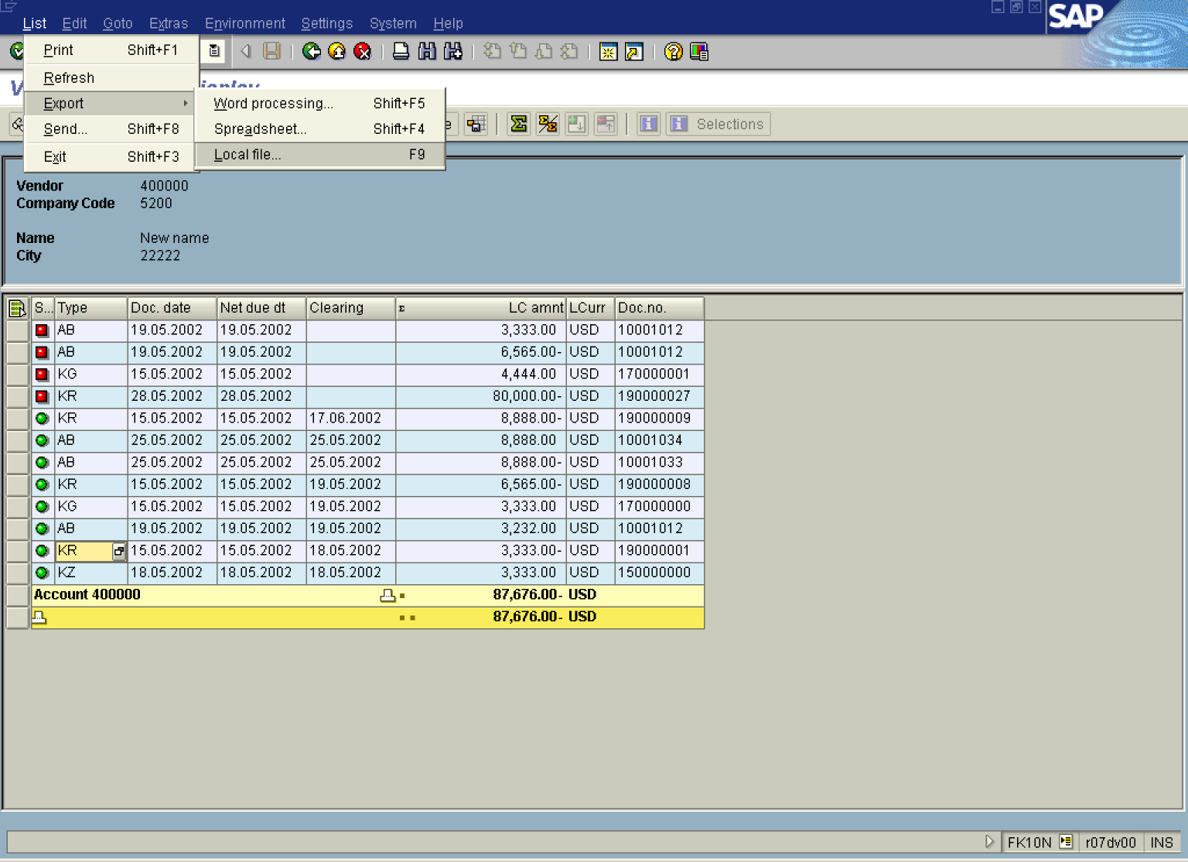

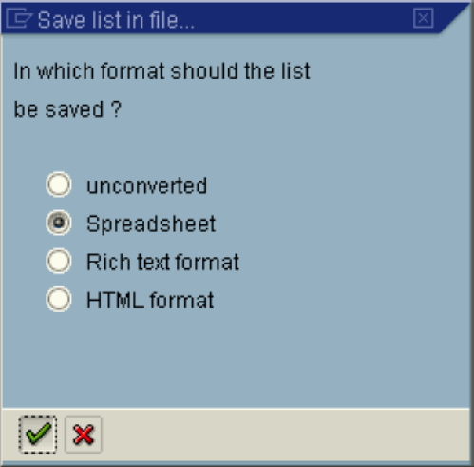
11. Mark “Spreadsheet” radio button and click Enter Button.

Transfer DAT to a Local File

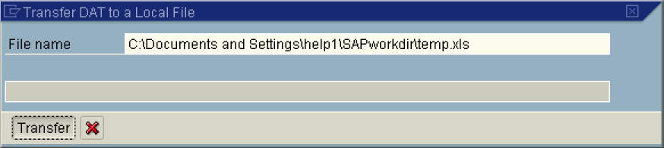

12. Update the following fields:

Field Name | Field Description | Values
File name | Enter here the path and name of your file | Example: C:\Documents and Settings\help1\SAPworkdir\temp.xls

13. Click Transfer Button to begin export.
14. The message bar displays “760 Bytes transferred”.

